**Ideation Phase**

**Define the Problem Statements**

|  |  |
| --- | --- |
| Date | 28 Jaune 2025 |
| Team ID | LTVIP2025TMID51009 |
| Project Name | Visualizing Housing  Market Trends: An  Analysis Of Sale Prices  And Features Using  Tableau |
| Maximum Marks | 2 Marks |

**Customer Problem Statement Template:**

Create a problem statement to understand your customer's point of view. The Customer Problem Statement template helps you focus on what matters to create experiences people will love.

A well-articulated customer problem statement allows you and your team to find the ideal solution for the challenges your customers face. Throughout the process, you’ll also be able to empathize with your customers, which helps you better understand how they perceive your product or service.

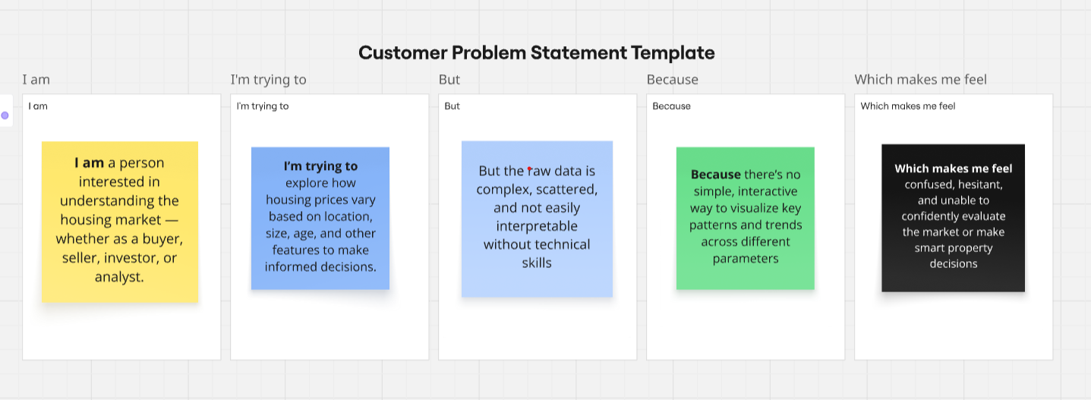

|  |  |  |  |  |  |
| --- | --- | --- | --- | --- | --- |
| **Problem Statement (PS)** | **I am (Customer)** | **I’m trying to** | **But** | **Because** | **Which makes me feel** |
| PS-1 | A first-time home buyer | |  | | --- | | Understand  how house  prices vary  across  different  areas and  features |  |  | | --- | |  | | |  | | --- | | The  Available  data is raw  and hard to  interpret |  |  | | --- | |  | | |  | | --- | | I don’t  have  tools or  experience to analyze large datasets |  |  | | --- | |  | | Confused, overwhelmed, and uncertain about my decision |
| PS-2 | A real estate agent | |  | | --- | | Show clients  price trends  and  feature-based value differences |  |  | | --- | |  | | |  | | --- | | I can’t easily visualize trends or compare different property types |  |  | | --- | |  | | |  | | --- | | The data  lacks  interactive  visuals  and takes  time to  explain  manually |  |  | | --- | |  | | Frustrated and less effective in serving my clients |

2.2 EMpathy map

